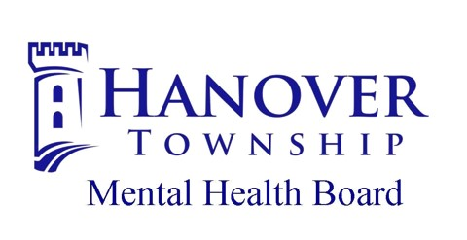

2025 Resource Guide

Dear Neighbor,

In 1977, the residents of Hanover Township voted to pass a referendum creating a Mental Health Board. The Mental Health Board is comprised of seven volunteers from the community that are appointed by the Township Supervisor to allocate the funds collected through the Community Mental Health Tax. These funds must be spent to support mental health services, substance use services, and intellectual/developmental disability services.
Over the years, the Hanover Township Mental Health Board has evolved with the community. Today, the Board funds 32 local providers and 47 different programs. One out of five Township residents receive services that are at least in part funded by the Mental Health Board. The Mental Health Board’s mission is to ensure that services in the areas of mental health, including developmental disabilities, addictions, and substance abuse, are available to all residents of Hanover Township. The Mental Health Board accomplishes this by funding services, but also supporting the providers through creating referral networks, providing funds for staff development to ensure the workforce is state of the art, and providing funds for capital needs so local providers can focus their funds on service.
The Mental Health Board conducts a Needs Assessment of the community every three years to ensure the services funded are the services needed. The Needs Assessment has led the Mental Health Board to seek out providers that can serve our multi-lingual community. The Needs Assessment has also driven the Mental Health Board’s involvement in Hanover Landing, a permanent supportive housing unit in Elgin that was completed in October of 2023. The Needs Assessment also identified that many residents of Hanover Township do not know where to go for mental health, substance use, or intellectual/developmental disability needs. The purpose of this guide to provide information to the community of the resources available.
In this Resource Guide, you will find vetted resources that serve Hanover Township in many capacities along with their contact information. Feel free to contact the Mental Health Board with questions or comments at (630)-837-0301 or at mhb@hanover-township.org.

Hanover Township Mental Health Board

Faiza Rahim, Chair
Mary Jane Garvey, Vice Chair
Michelle Esquivel, Secretary
Denise Noyola, Trustee Liaison
Matt Steichmann
Heidi McGuire
Maria Wywialowski

Mission Statement
The Hanover Township Mental Health Board ensures that services in the areas of mental health, including developmental disabilities, addictions and substance abuse, are available to all residents of Hanover Township.
Table of Contents
Addiction Services……………………………………………………5
Advocacy (Information and Referrals).…………………………7
Crisis Services…………………………………………………………8
Developmental Disability Programs…………………………...9
Domestic Violence and Sexual Assault………………………11
Food Pantries…………………………………………………………12
Financial Literacy and Counseling…………………………….14
Healthcare and Dental Clinics ………………………………….15
Helplines and Hotlines ……………………………………………16
Legal Assistance …………………………………………………….17
Mental Health Services ……………………………………………18
Shelters ……………………………………………………………… 20
Youth Mental Health and Prevention Services …………… 21

Disclaimer: This guide has been compiled based on information provided by various resources. Although information has been checked and researched, it is possible that some information is missing or incorrect. Changes to programs or services may occur after the date of publication.
A listing in this guide does not guarantee that services will be provided; does not imply any type of contract with, referral to, or recommendation for any provider or agency listed within this guide; and is to be used solely for informational purposes. If your agency does appear in the guide and information needs to be updated, please email us at mhb@hanover-township.org or call the Mental Health Board offices at (630) 837-0301.
**Please note agencies marked with a + are currently receiving annual funding from the Hanover Township Mental Health Board.

Addiction Services
About Behavioral Change+
1375 E Schaumburg Road Suite #120
Schaumburg, IL 60193

https://www.aboutbehavioralchange.org/
Phone: English (847) 791-4384
Spanish (815) 219-9849

Ascension Illinois
801 Gloucester Drive
Elk Grove Village, IL 60007
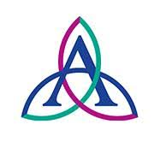
https://healthcare.ascension.org/
Phone: (847) 981-5000

Ecker Center for Behavioral Change+
1845 Grandstand Place
Elgin, IL 60123
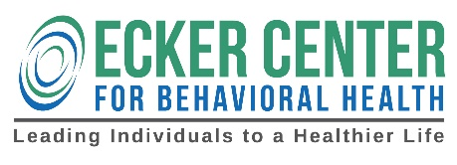
https://www.eckercenter.org/
Phone: (847) 695-0484

Footprints to Recovery
411 W River Road
Elgin, IL 60123
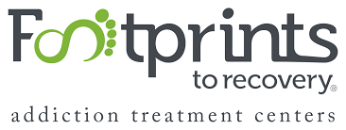
https://footprintstorecovery.com/
Phone: (847) 281-5394

Latino Treatment Center
54 S Grove Avenue
Elgin, IL 60120
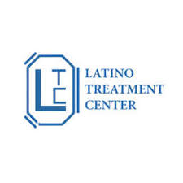
https://latinotreatmentcenter.com/
Phone: (847) 695-9155

Lighthouse Recovery
210 South 5th Street Suite #10
St. Charles, IL 60174
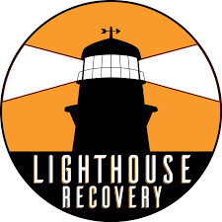
https://lighthouserecoveryinc.com/
Phone: (630) 940-2468

Lutheran Social Services of Illinois
675 Varsity Drive
Elgin, IL 60120

https://www.lssi.org/
Phone: (833) 610-5774

The SHARE Program
1776 Moon Lake Boulevard
Hoffman Estates, IL 60169

https://www.leydenfamilyservice.org/substance-abuse-share
Phone: (847) 882-4181

Advocacy (Information and Referral)


Centro De Informacíon+
1885 Lin Lor Lane
Elgin, IL 60123
https://centrodeinformacion.org/
Phone: (847) 695-9050

Hanover Township Human Services
7431 Astor Avenue
Hanover Park, IL 60133


https://www.hanover-township.org/departments/human-services
Phone: (630) 540-9085
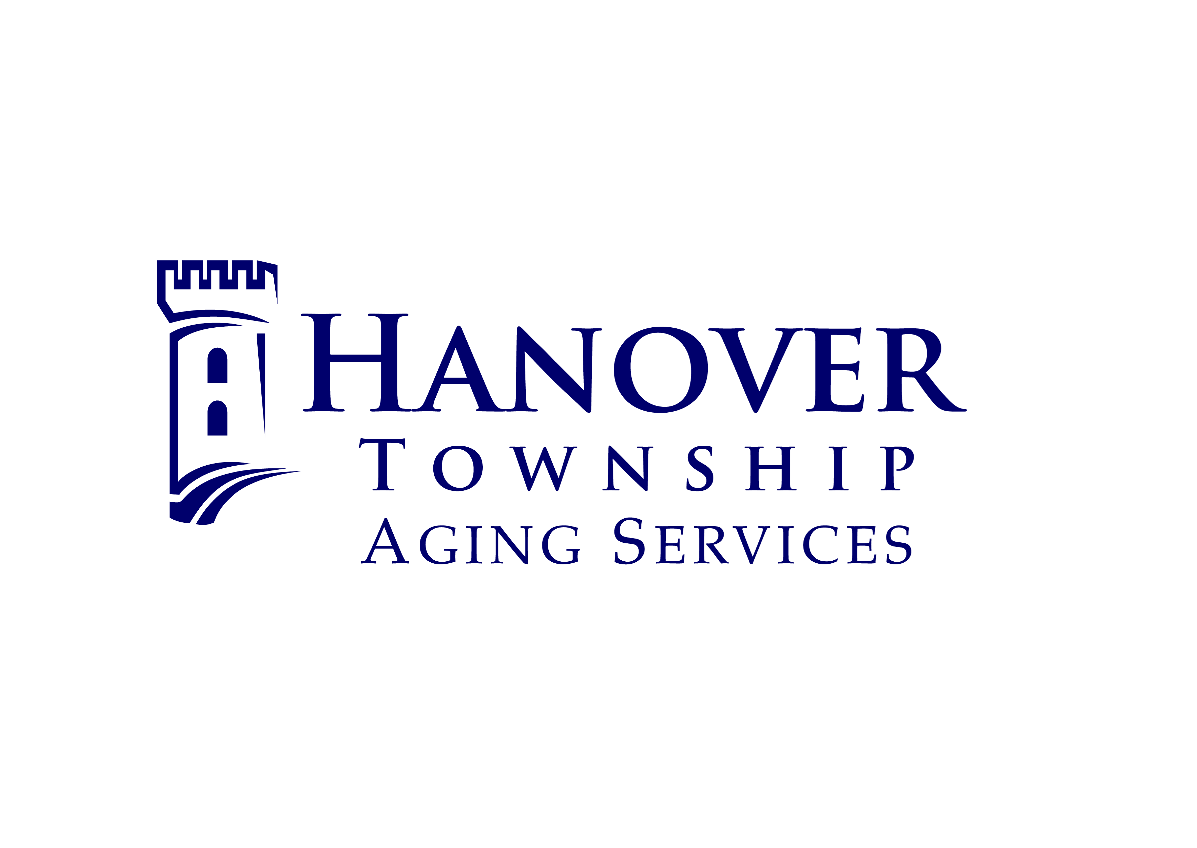

Hanover Township Social Services+
240 South IL Route 59
Bartlett, IL 60103
https://www.hanover-township.org/departments/senior-services/social-services
Phone: (630) 483-5660

Partners for Our Communities+
1515 E Lake Street
Hanover Park, IL 60133
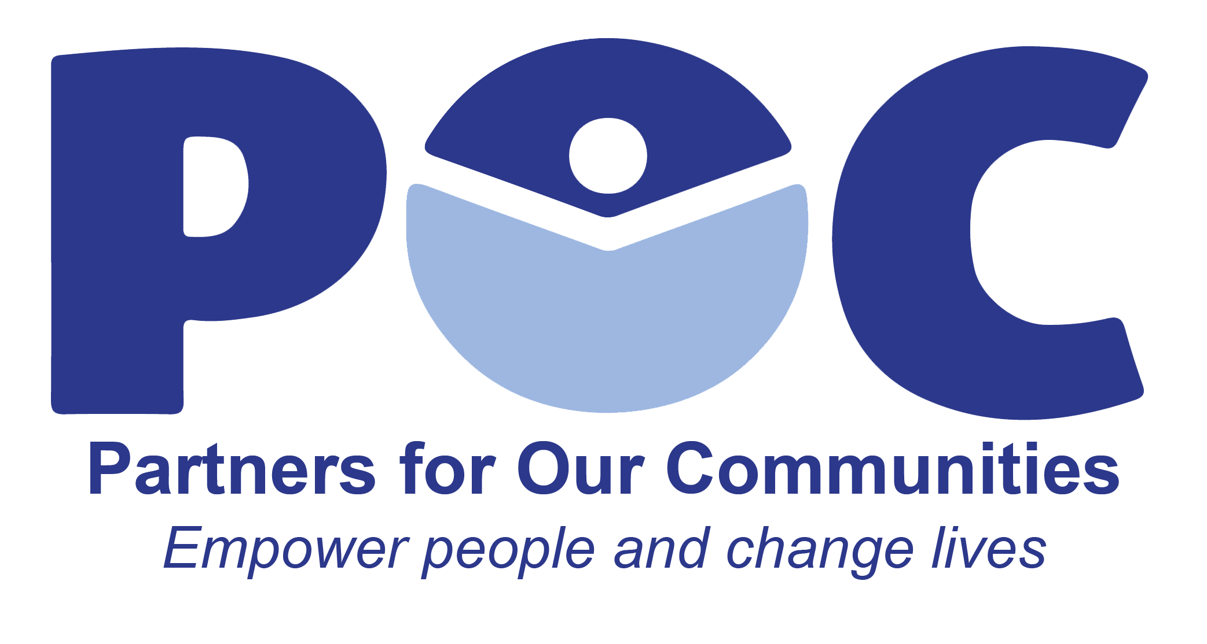

https://www.poc.news/
Phone: (847) 776-9500

Crisis Services
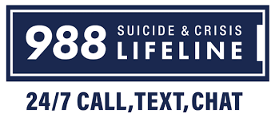
988
National Crisis Hotline

Association for Individual Development+
309 New Indian Trail
Aurora, IL 60506
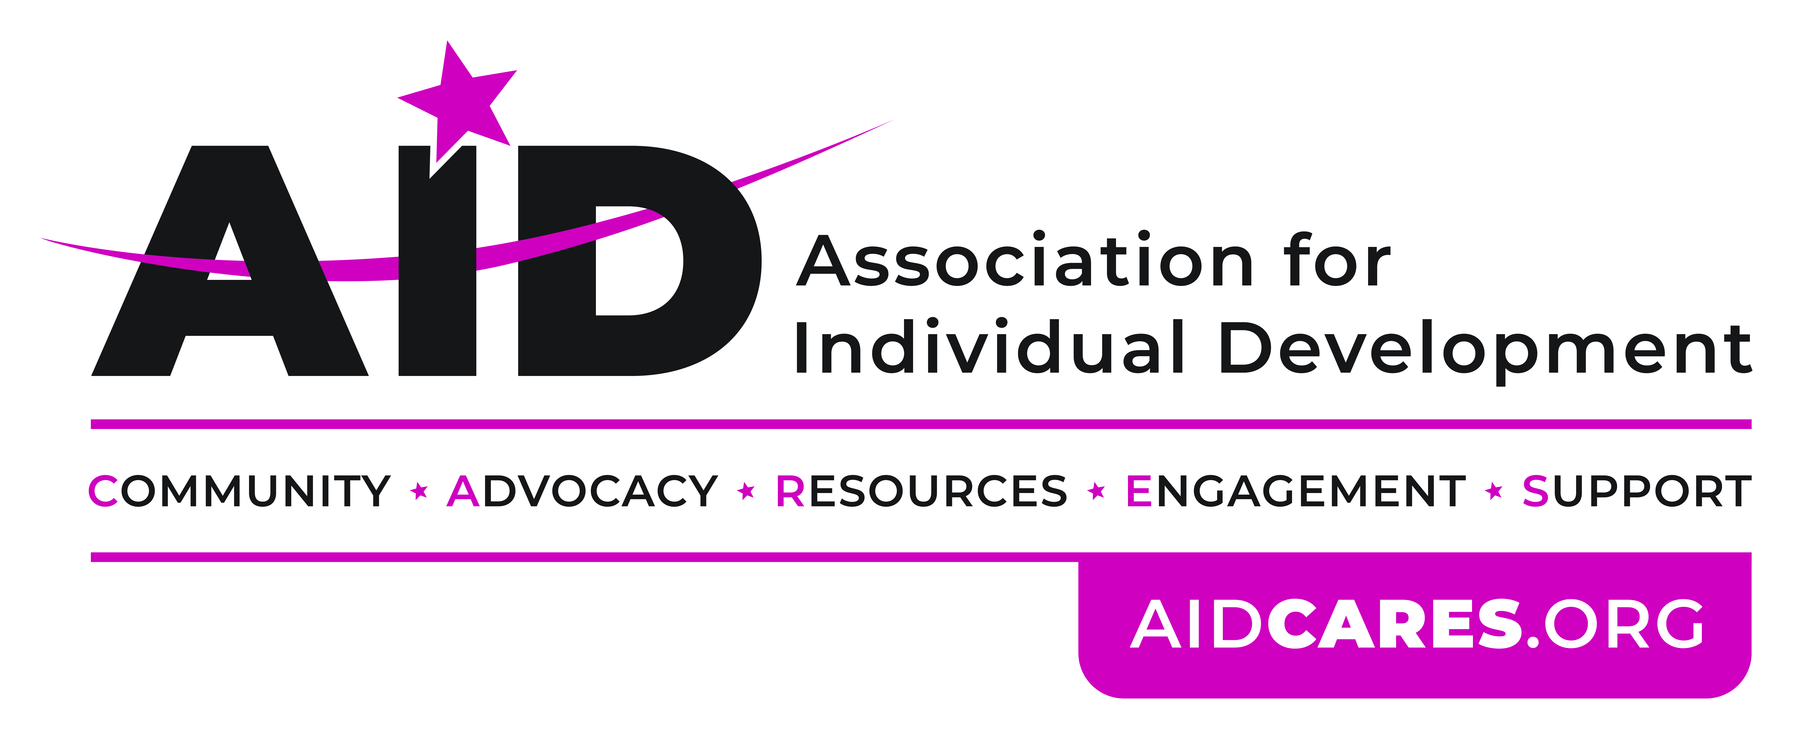

https://www.aidcares.org/crisis-community-outreach/
Phone: (630) 966-9393

Ecker Center for Behavioral Change+
1845 Grandstand Place
Elgin, IL 60123
https://www.eckercenter.org/
Phone: (888) 325-3750

Family Services Association of Greater Elgin+
1752 Capital Street
Elgin, IL 60124
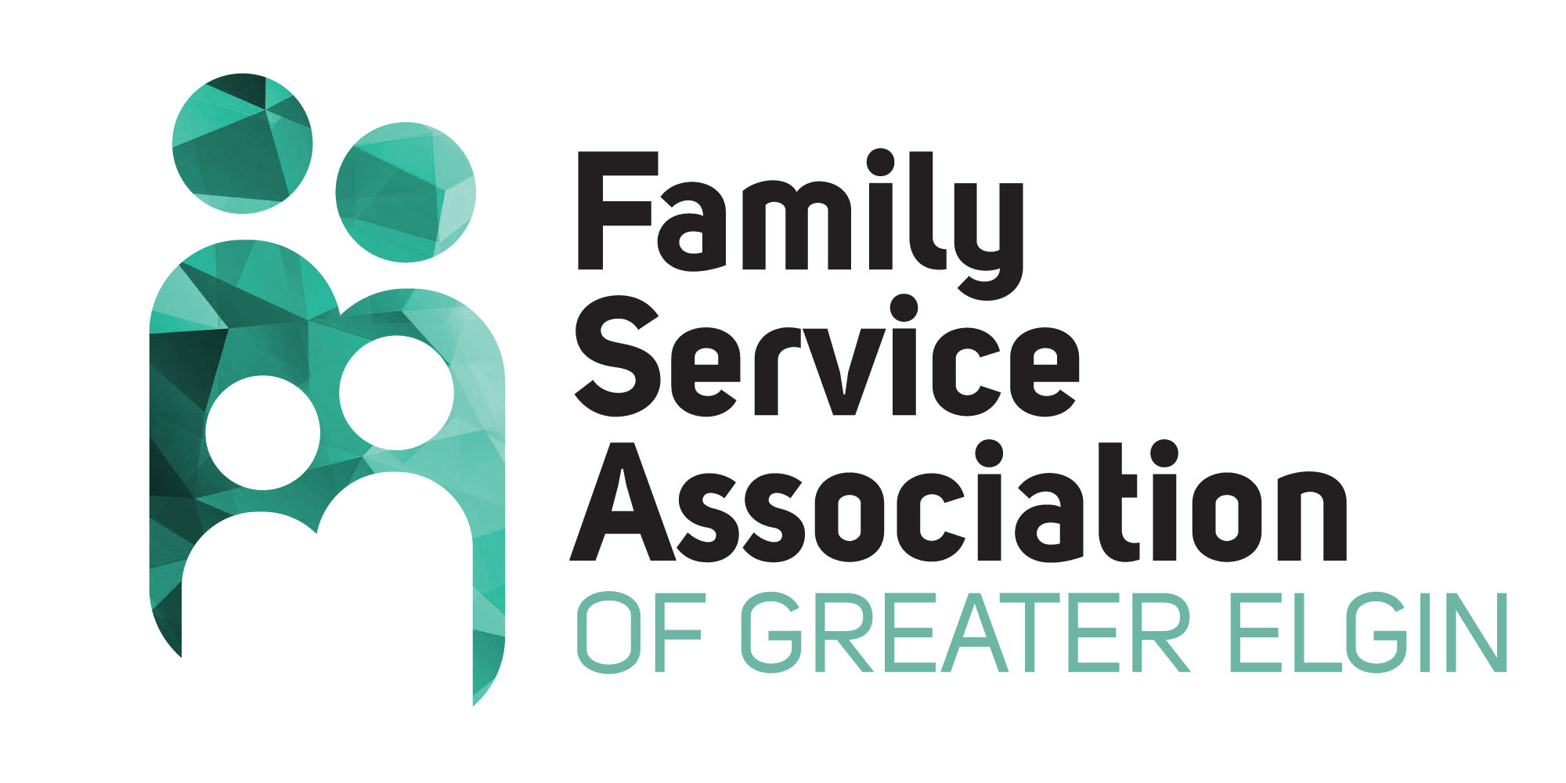

https://fsaelgin.org/
Phone: (847) 695-3680

Kenneth Young Center**+
1001 Rohlwing Road
Elk Grove Village, IL 60007
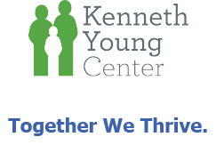

https://www.kennethyoung.org/
Phone: (800) 346-9049
**indicates services for youth
Developmental Disability Services
Association for Individual Development+
309 New Indian Trail
Aurora, IL 60506

https://www.aidcares.org/
Phone: (630) 966-4000

Clearbrook+
1835 W Central Road
Arlington Heights, IL 60005


https://www.clearbrook.org
Phone: (847) 870-7711

Community Alternatives Unlimited+
8765 W Higgins Road, Suite 300
Chicago, IL 60631
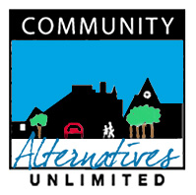
https://www.cau.org/
Phone: (773) 867-4055

Easterseals of DuPage & Fox Valley+
830 South Addison Avenue
Villa Park, IL 60181


https://www.easterseals.com/dfv/
Phone: (630) 620-4433

Developmental Disability Services
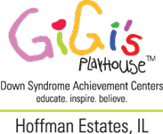
Gigi’s Playhouse+
2350 W Higgins Road
Hoffman Estates, IL 60169
https://gigisplayhouse.org/hoffmanestates/
Phone: (847) 885-7529

Little City+
1760 West Algonquin Road
Palatine, IL 60067

https://littlecity.org/
Phone: (847) 358-5510

Marklund+
1210 Hunter Drive
Elgin, IL 60120


https://www.marklund.org/
Phone: (630) 593-5500

Ray Graham+
901 Warrenville Road, Suite 500
Lisle, IL 60532


https://www.raygraham.org/
Phone: (630) 620-2222

Domestic Violence and Sexual Assault

Community Crisis Center+
37 S Geneva Street
Elgin, IL 60120
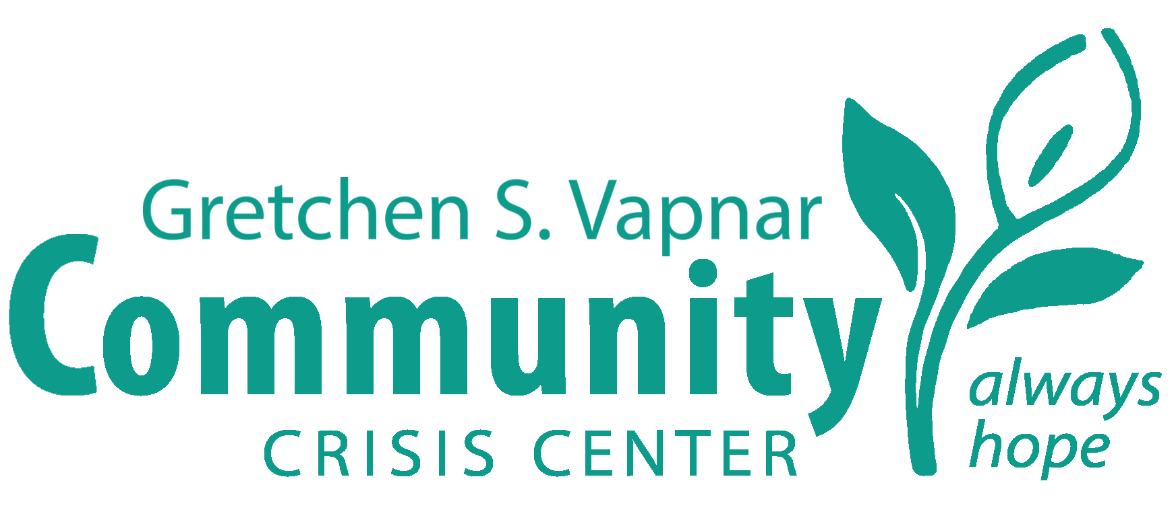

https://www.crisiscenter.org/
Phone: Crisis Hotline
English: (847) 697-2380
Español: (847) 697-9740

Northwest Center Against Sexual Assault+
415 West Golf Road
Suite 47
Arlington Heights, IL 60005
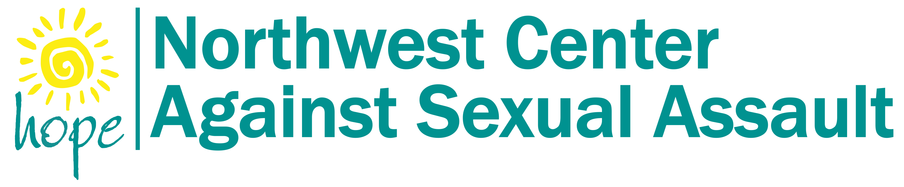

https://nwcasa.org/
Phone: (847) 806-6526
WINGS+
P.O Box 95615
Palatine, IL 60095

https://wingsprogram.com/
Phone: Hotline (847) 221-5680

Food Pantries
All People’s Interfaith Pantry
265 E Chicago Street
Elgin, IL 60120
Phone: (847) 741-2329

Community Crisis Center Food Bank
37 S Geneva Street
Elgin, IL 60120
Phone: (847) 742-4088

Food For Greater Elgin
1553 Commerce Drive
Elgin, IL 60123
Phone: (847) 931-9330

Hands of Hope Food Distribution Center
5700 Bartels Road
Hanover Park, IL 60133
Phone: (630) 671-1570

Hanover Township Astor Avenue Community Center
7431 Astor Ave
Hanover Park, IL 60133
Phone: (630) 540-9085

Food Pantries
Schaumburg Township Food Pantry
1 Illinois Blvd #107
Hoffman Estates, IL 60169
Phone: (847) 884-0030 ext: 1013

Well Child Center Food Distribution Center
620 Wing Street
Elgin, IL 60123
Phone: (847) 741-7370

Financial Literacy and Counseling
Consumer Credit Counseling Services of Northern Illinois
620 Wing Street
Suite 4
Elgin, IL 60123


https://www.illinoiscccs.org/
Phone: (815) 338-5757

Fellowship Housing+
2500 W Higgins Road
Suite #360
Hoffman Estates, IL 60169
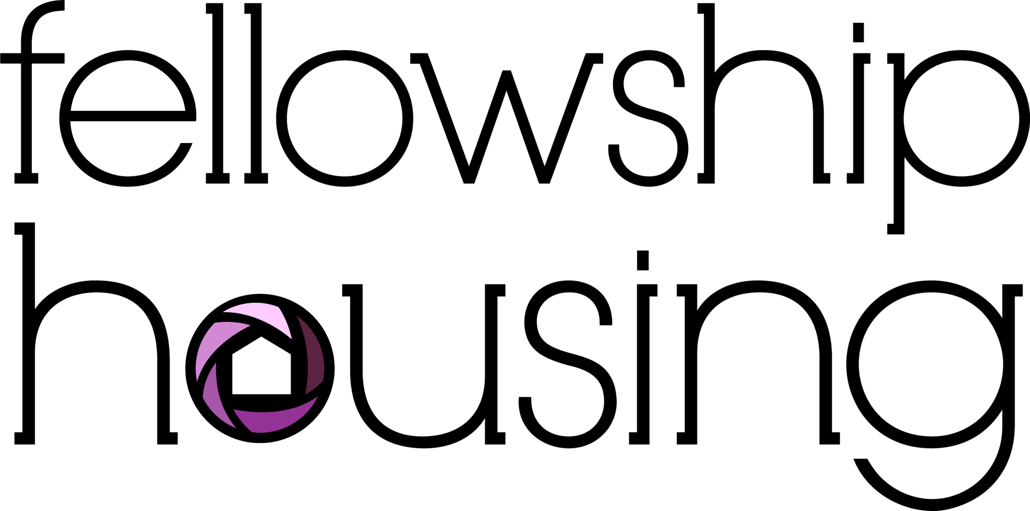

https://www.fhcmoms.org/
Phone: (847) 882-2511

Healthcare and Dental Clinics
Greater Family Health
135 E Irving Park Road
Streamwood, IL 60107

https://greaterfamilyhealth.org/
Phone: (844) 599-3700

Hanover Township Office of Community Health
240 S IL Route 59
Bartlett, IL 60103
https://www.hanover-township.org/departments/community-health
Phone: (630) 483-5665

Oak Street Health
822 Summit Street #84
Elgin, IL 60120

https://www.oakstreethealth.com/
Phone: (866) 919-9227

Well Child Center
620 Wing St.
Elgin, IL 60123


https://www.wellchildcenter.org/
Phone: (847) 741-7370

Helplines and Hotlines

988
Suicide and Crisis Hotline-can connect to local providers

888-ECKER-50
Mental Health Crisis line through Ecker Center

847-383-0406
Mental Health Crisis Line through Kenneth Young Center

847-697-2380
English Domestic Violence Hotline through Community Crisis Center

847-697-9740
Spanish Domestic Violence Hotline through Community Crisis Center

Legal Assistance
Administer Justice
1750 Grandstand Place
Elgin, IL 60123
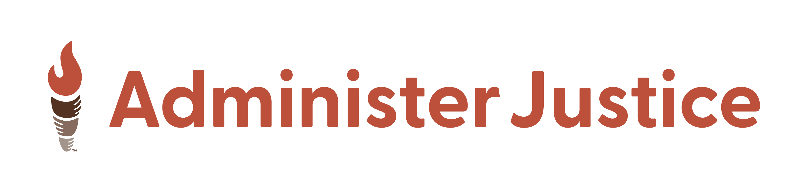
https://www.administerjustice.org/
Phone: (855) 818-4554

Centro De Informacion+
1885 Lin Lor Lane
Elgin, IL 60123


https://centrodeinformacion.org/
Phone: (847) 695-9050

Legal Aid of Chicago
120 S LaSalle Street
Chicago, IL 60603

https://legalaidchicago.org/
Phone: (312) 341-1070

Partners For Our Communities+
1515 W Lake Street
Hanover Park, IL 60133

https://www.poc.news/
Phone: (847) 776-9500

Mental Health Services
Association for Individual Development+
309 New Indian Trail
Aurora, IL 60506

https://www.aidcares.org/
Phone: (630) 966-4000

Ascension Alexian Brothers Center for Mental Health+
3436 N Kennicott Ave
Arlington Heights, IL 60004


https://healthcare.ascension.org/locations/illinois/ilchi/arlington-heights-ascension-illinois-center-for-mental-health
Phone: (847) 952-7460

Ecker Center for Behavioral Change+
1845 Grandstand Place
Elgin, IL 60123
https://www.eckercenter.org/
Phone: (888) 325-3750

Kenneth Young Center**+
1001 Rohlwing Road
Elk Grove Village, IL 60007

https://www.kennethyoung.org/
Phone: (800) 346-9049
**indicates services for youth

Mental Health Services
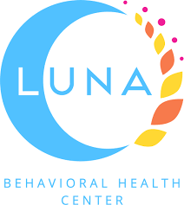
Luna Behavioral Health Center
164 Division Street
Suite 607
Elgin, IL 60120
https://www.lunabehavioralhealthcenter.com/
Phone: (847) 217-9797

Pivotal Counseling
665 Tollgate Road
Elgin, IL 60123


https://pivotalcounselingcenter.com/locations/counseling-in-elgin-il/
Phone: (815) 345-3400

Shelter Services
Journeys The Road Home+
1140 E Northwest Highway
Palatine, IL 60074

https://www.journeystheroadhome.org/
Phone: (847) 963-9163

Lazarus House
214 Walnut Street
St. Charles, IL 60174


https://www.lazarushouse.net/
Phone: (630) 587-2144

PADS of Elgin+
1730 Berkley Street
Elgin, IL 60123

https://padsofelgin.org/
Phone: (847) 608-9744

Shelter, Inc. **+
1616 N Arlington Heights Rd
Arlington Heights, IL 60004
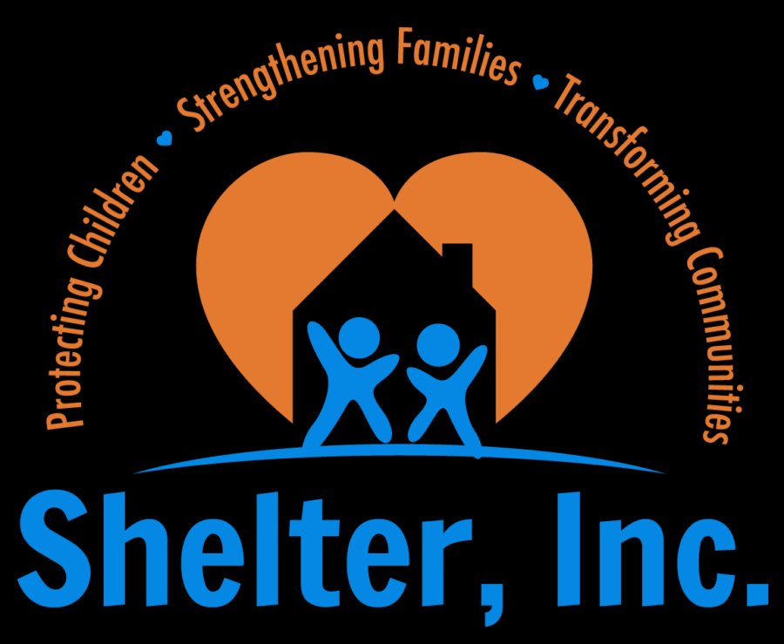
https://www.shelter-inc.org/
Phone: (847) 255-8060

Youth Mental Health and Prevention
Children’s Advocacy Center of North and Northwest Cook County+
640 Illinois Blvd.
Hoffman Estates, IL 60169
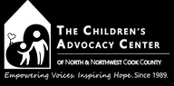
https://www.cachelps.org/
Phone: (847) 885-0100

Family Services Association of Greater Elgin +
1752 Capital Drive
Elgin, IL 60124
https://fsaelgin.org/

Phone: (847) 695-3680

Hanover Township Youth and Family Services+
250 S IL Route 59
Bartlett, IL 60103

https://www.hanover-township.org/departments/youth-and-family-services
Phone: (630) 483-5799

Kenneth Young Center**+
1001 Rohlwing Road
Elk Grove Village, IL 60007

https://www.kennethyoung.org/
Phone: (800) 346-9049
**indicates services for youth

Youth Mental Health and Prevention

Northeast DuPage Family Services
777 Army Trail Blvd. FL 2
Addison, IL 60101

https://www.nedfys.org/
Phone: (630) 693-7934

The Bridge Youth and Family Services+
721 S Quention Road #103
Palatine, IL 60067
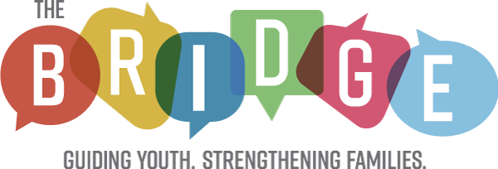
https://bridgeyouth.org/
Phone: (847) 359-7490

